**ASSIGNMENT-13**

U19CS012

1. Simulate an Active High Pass Filter Circuit [High Pass Filter using OPAMP]

**Circuit Diagram [Multisim Implementation]**

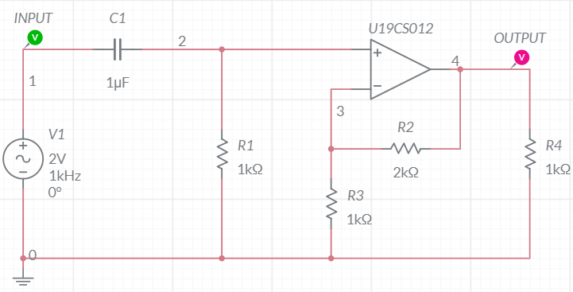

**Grapher Image [AC Sweep]**

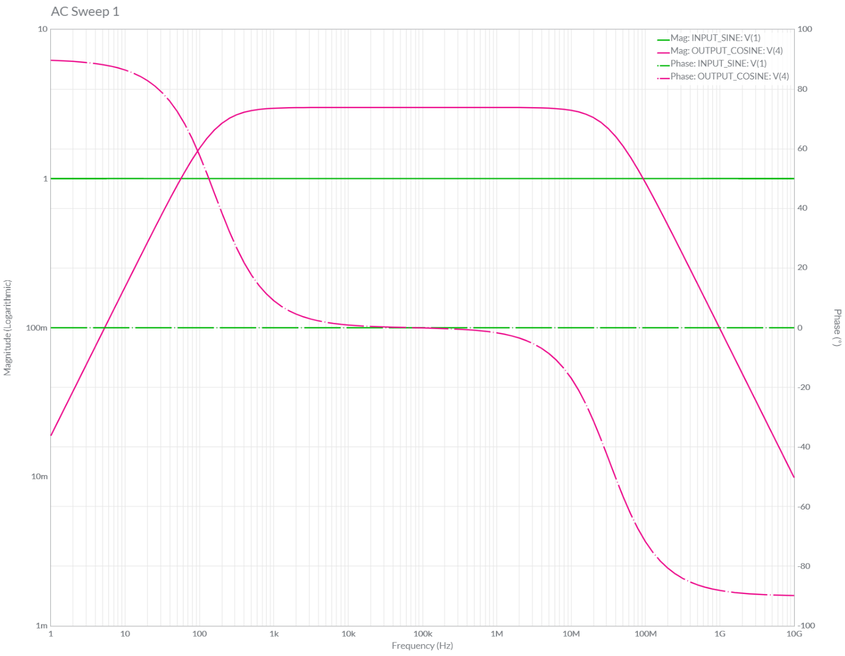

**Circuit Diagram [Offline Multisim Implementation]**

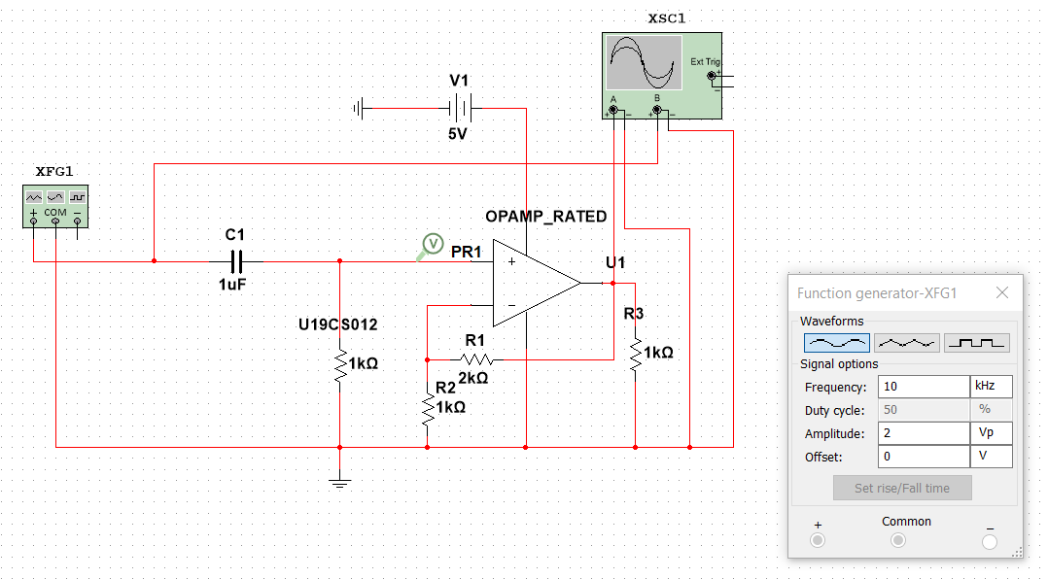

**Grapher Image [Offline Multisim AC Sweep]**

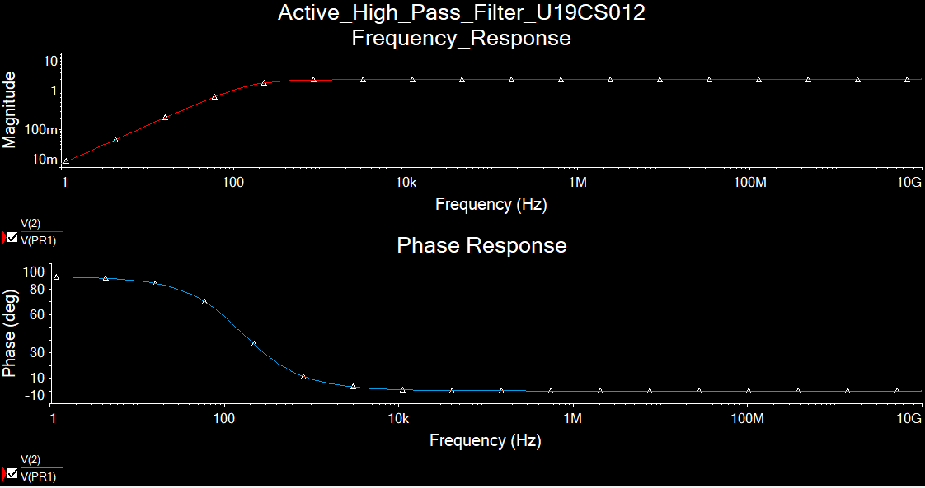

2. Simulate an Active High Pass Filter Circuit as Differentiator

[Differentiation of (Sine Wave) = + Cosine Wave]

**Circuit Diagram [Multisim Implementation]**

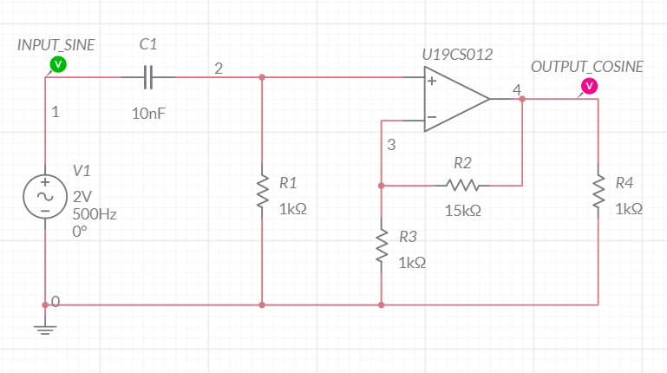

**Grapher Image [Transient]**

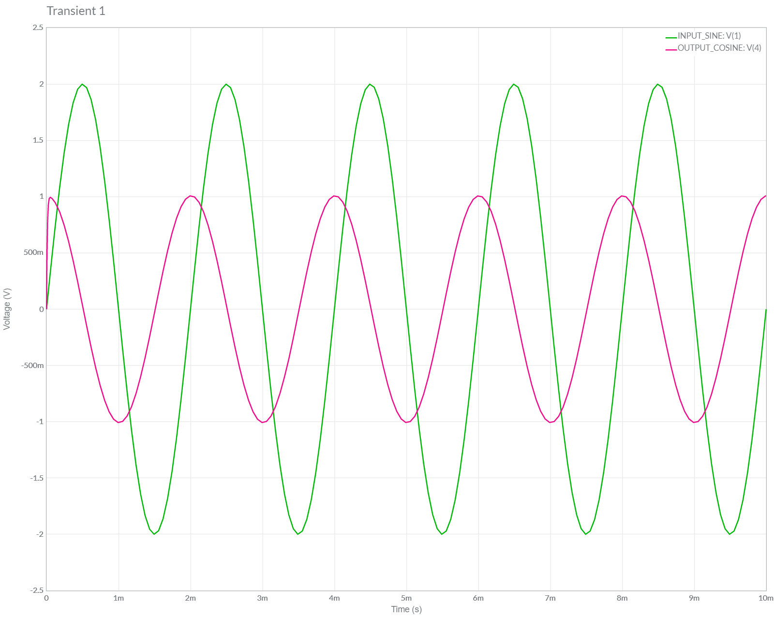

3. Simulate an Active High Pass Filter Circuit as Differentiator

[Differentiation of (Triangular Wave) = Square Wave]

**Circuit Diagram [Multisim Implementation]**

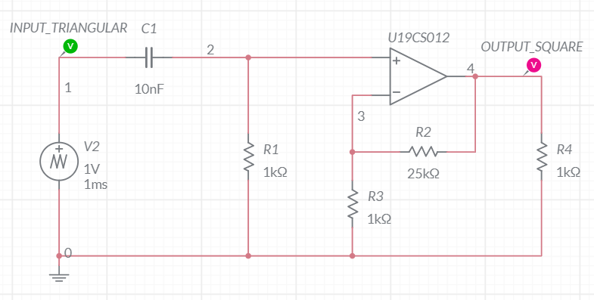

**Grapher Image [Transient]**

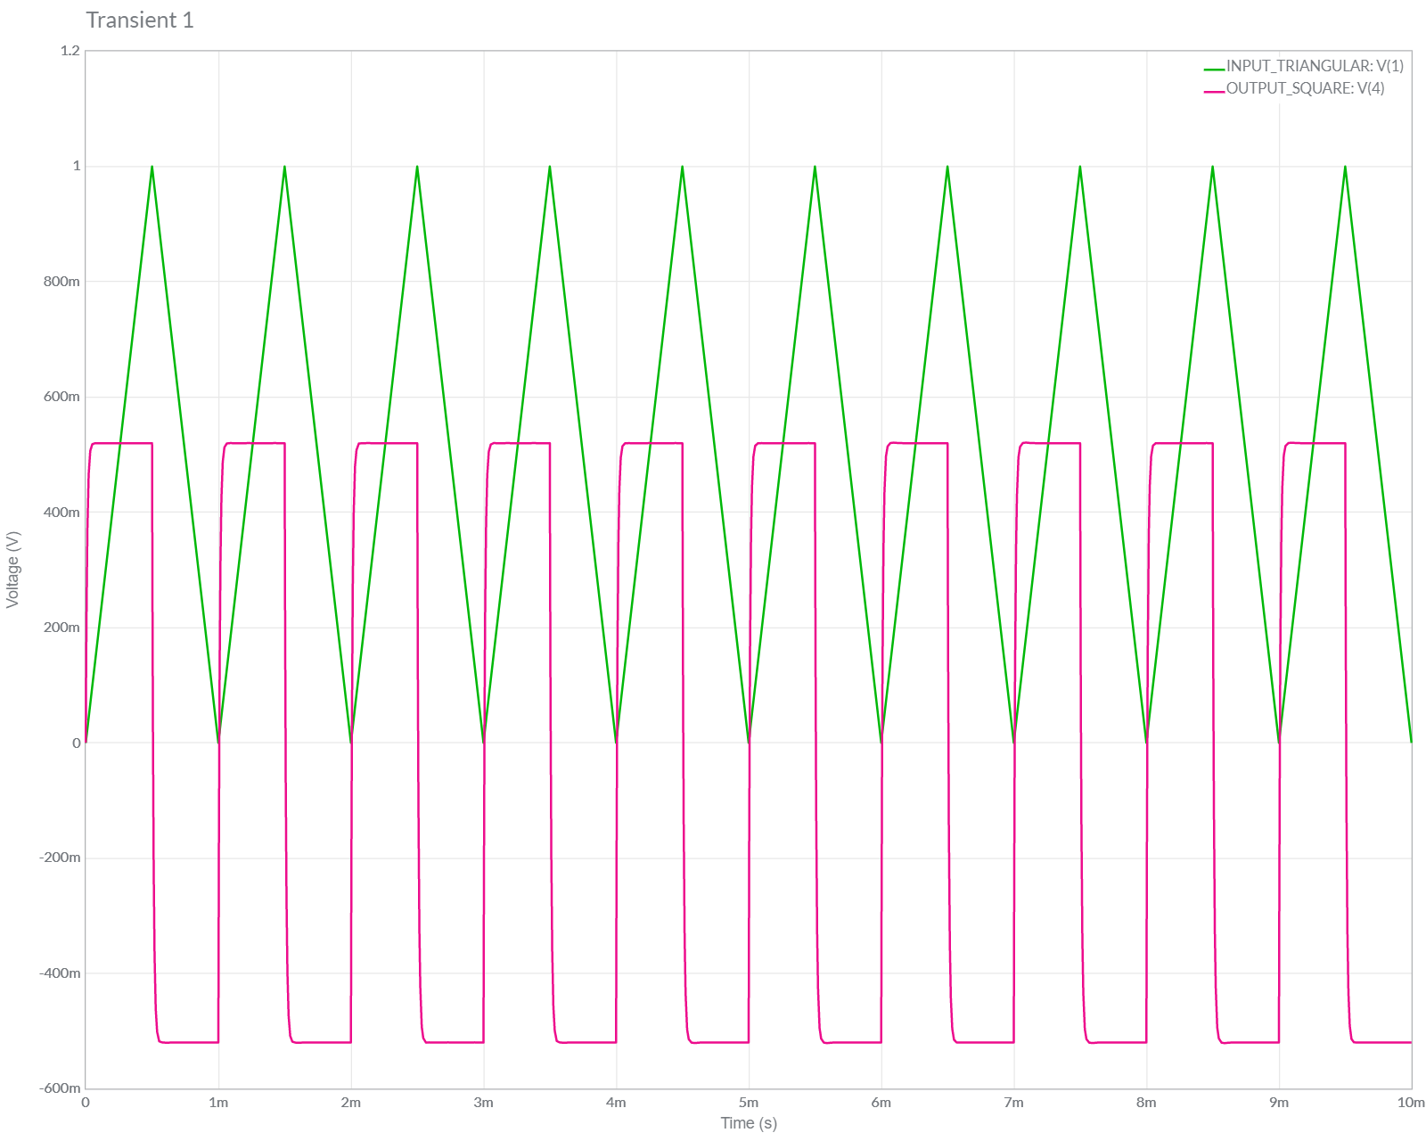

4. Simulate an Active High Pass Filter Circuit as Differentiator

[Differentiation of (Square Wave) = Spikes Wave]

**Circuit Diagram [Multisim Implementation]**

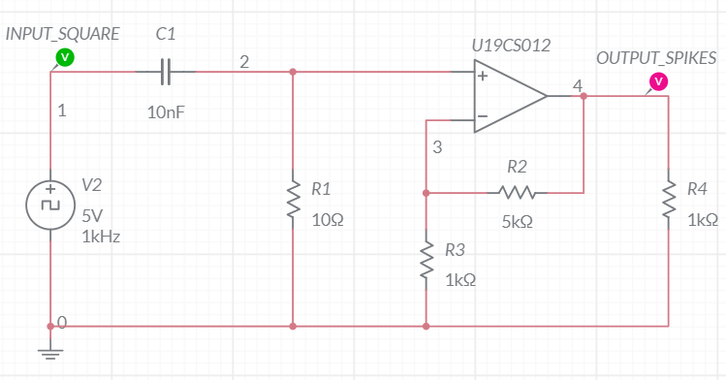

**Grapher Image [Transient]**

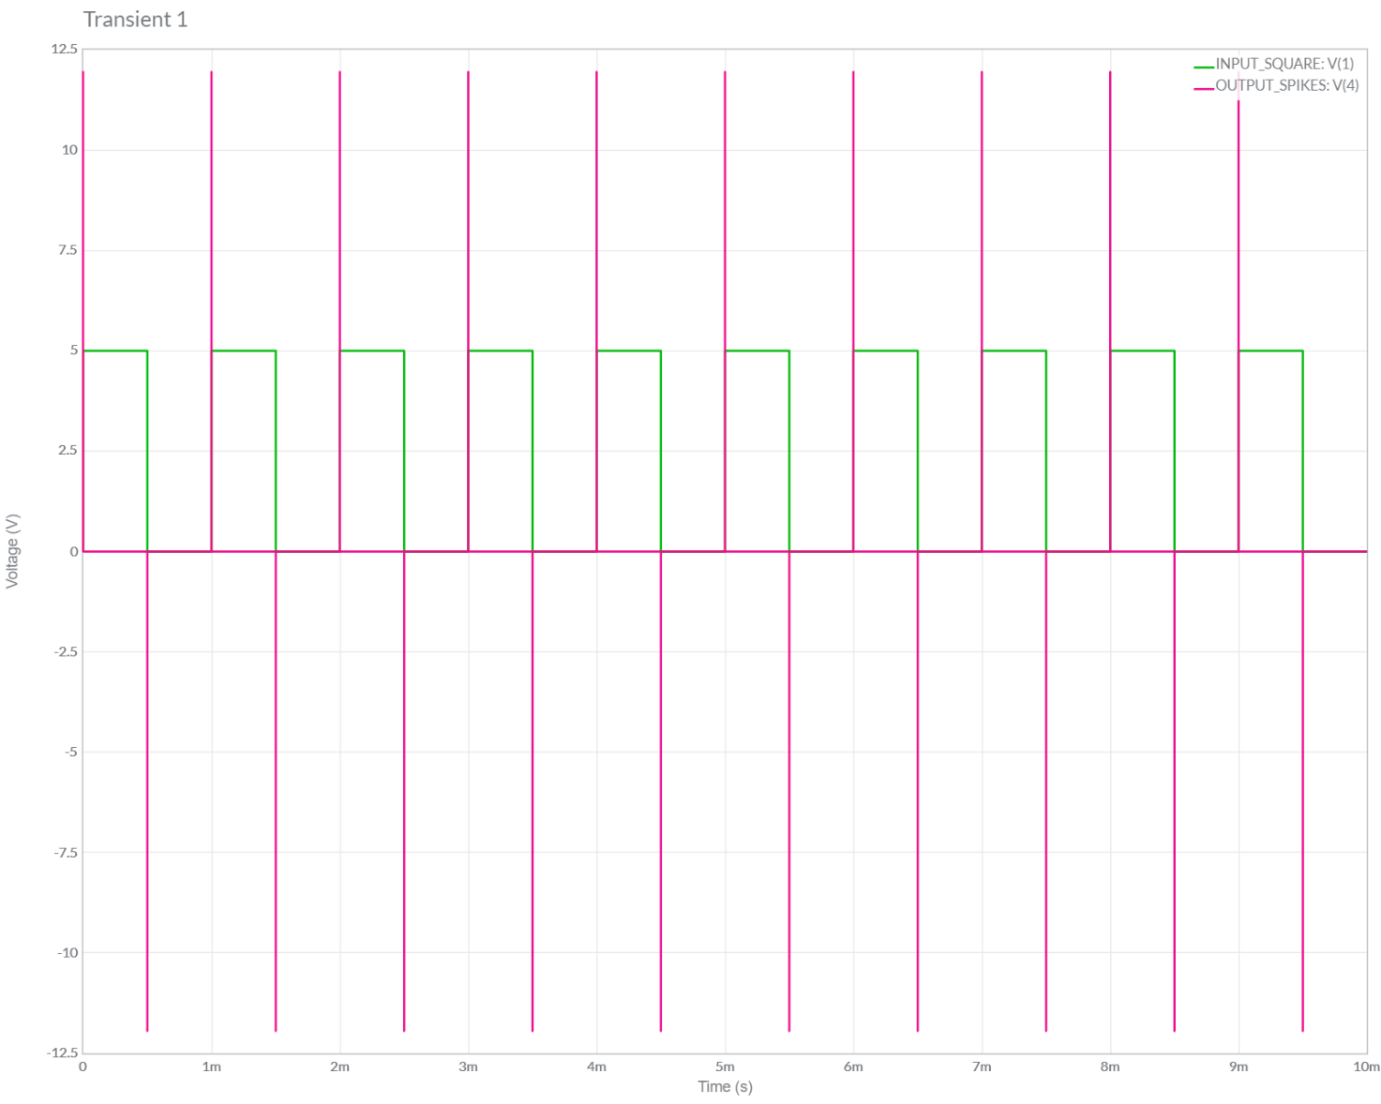

5. Simulate an Active Low Pass Filter Circuit [High Pass Filter using OPAMP] [EXTRA] [OPAMP as Buffer]

**Circuit Diagram [Multisim Implementation]**

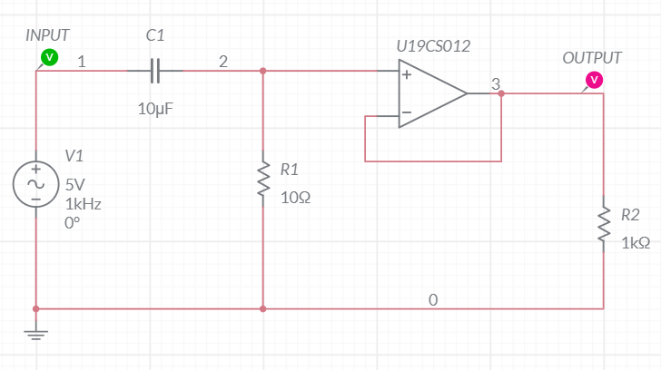

**Grapher Image [AC Sweep]**

